Assignment-1.
Code –
public class Student {
// Private member variables
private String studentName;
private String collegeName;
private int studentID;

// Main method
public static void main(String[] args) {
System.out.println("Successful");
}
}
Output –
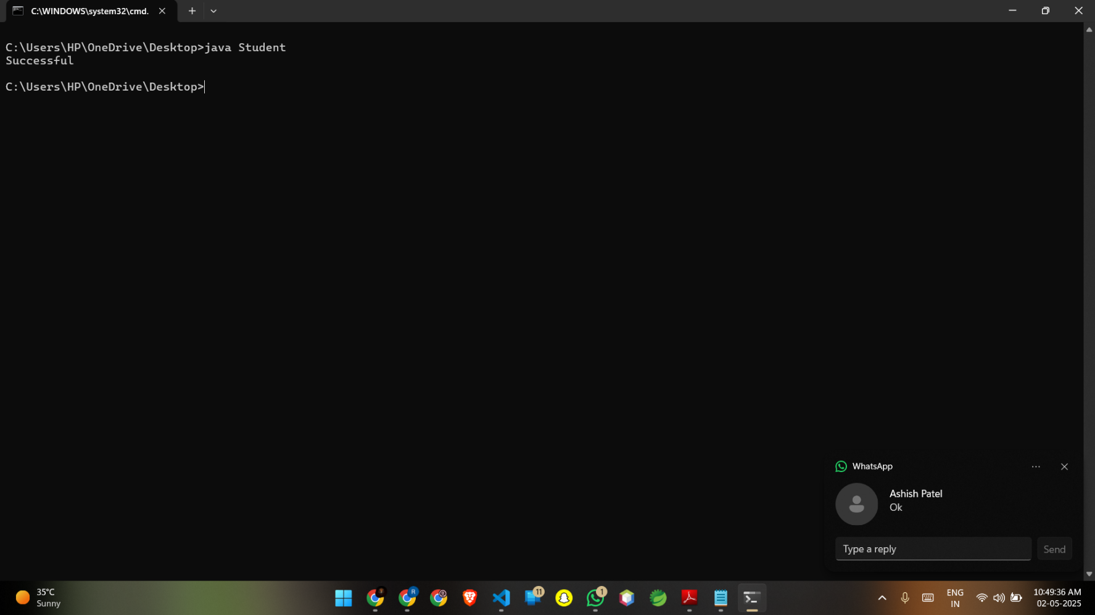
Assignment-2.
Code –
// Employee.java
public class Employee {
// Protected member variables
protected int id;
protected int age;
protected String name;
protected boolean isPermanent;

public static void main(String[] args) {
Employee emp = new Employee();
emp.age = (int) 35.5;
System.out.println("Successfully started");
}
}
Output
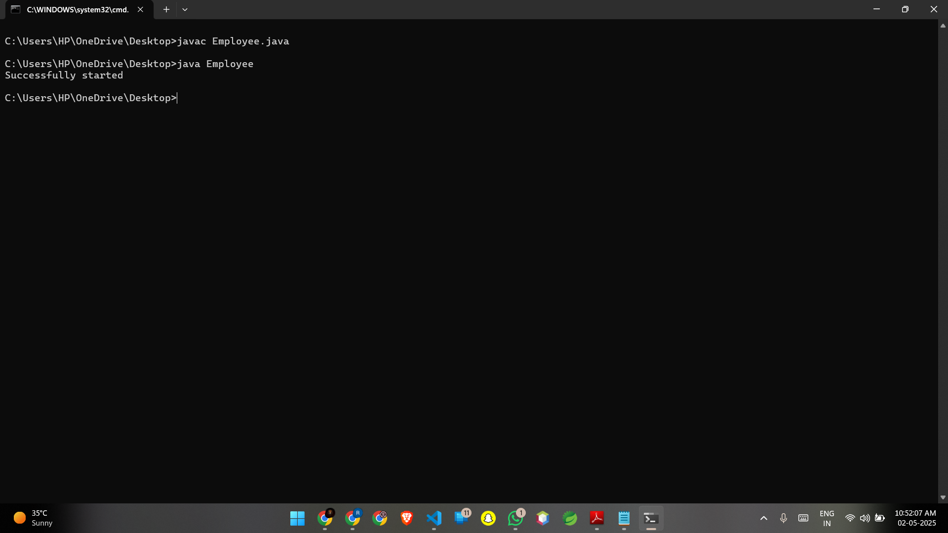
Assignment- 3.
Code –
public class Person {
String name;
int age;
int salary;
// Main method
public static void main(String[] args) {
System.out.println("Test Successful");
}
}
Output – 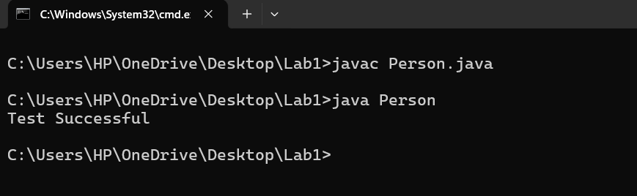
Assignment- 4.
Code –
public class Rectangle {

double width;
double height;

// Enum definition
enum Color {
RED, GREEN, BLUE
}

// Member variable of type Color
Color boxColor;

// Main method
public static void main(String[] args) {
// Print the enum value
System.out.println(Color.BLUE);
}
}
Output
